|  |  |  |
| --- | --- | --- |
| **شعار جامعة بنها الجديد**f |  | **logo.jpg** |
| Benha University |  | Faculty of Computers & Informatics |

**F e k r a**

A summer training project submitted in partial fulfillment of the requirements for the degree of Bachelor of Computers and Informatics.

**1st Year Students Summer Training**

*Project Team*

1. Hesham Ayman
2. Nada Mohamed
3. Noha Emad
4. Wael Mohamed
5. Wasem Edwer

Benha, August 2015

We hereby certify that this project, submitted by the project teamwork, conforms to acceptable standards and is fully adequate in scope and quality to fulfill the seminar requirements for the degree of Bachelor of Computers and Informatics.

**Discussion Committee:**

____________________________________ ________________

Date

____________________________________ ________________

Date

____________________________________ ________________

Date

**Abstract**

**this project offers an easy way to search about a particular book By many ways such as : The name of the book , the author or the name of the category, It provides the possibility of additional new books .**

**Introduction**

**There are a lot of problems such as the addition of new books and the search for a specific book and the process of organizing and collecting books and the solution to this problem is to divide books into specific categories , searching by book or author for easy to find the book and save time and effort .**

**Program Interface**

**İn the first form there are two buttons , the first one is to start program and the second one to update data.**

**When you press on the button named start program you will move on to the search form which contains three textboxes , three buttons the first one is to search for a book by category and the second is to search a book**

**By the name of the book and the third is to seacrch by the book name .**

**at the end of this form there is a button named buy when you press it will move you to the bill form which contains the library name, buyer name , price , the date of sell , address ,telephone .**

**There is another button in the first form named update data when you press it you will move to updateData form which contains a combobox include the categories of the books ,the book name , author ,date of issue ,page numbers , price , two buttons one to add books and the other one to close the updateDate form .**

**Program Execution**

**the functionality of the program is search about aparticular books and add new books .**

**in the first form there are two buttons the first one to start the program and the second one is to update data**

**when you press on start program button you will move to the search form in this form there are three textboxes to input data to search for it , there are three buttons the first one is to search by category , the second one is to search for a book by the author name and the third one is to search for abook by the book name and the result of the search will appear at the listbox .**

**at the end you should press on buy button and you will move to the bill form to fill it will the library name,buyer name , book name ,the date of sell ..**

**Input and Output**

**İn the search form . there are three input the first one is to search for a book by category , the second one is to search for a book by author name , the third way is to search for a book by the book name .**

**The output will be shown in a listbox included information about the book such as the book name, author , the date of issue , the number of pages and the price .**

**If the user searched for a book that not existed In the file in this case it will be shown a messagebox report the user that this book not exist .**

**Program Structure**

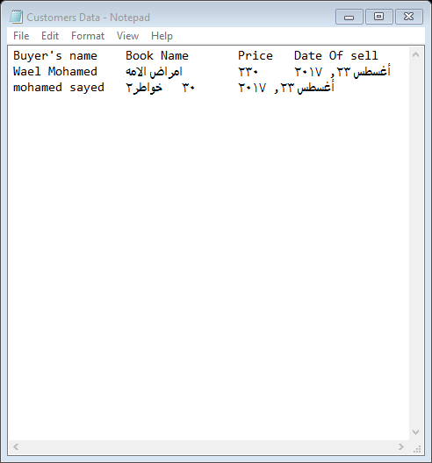

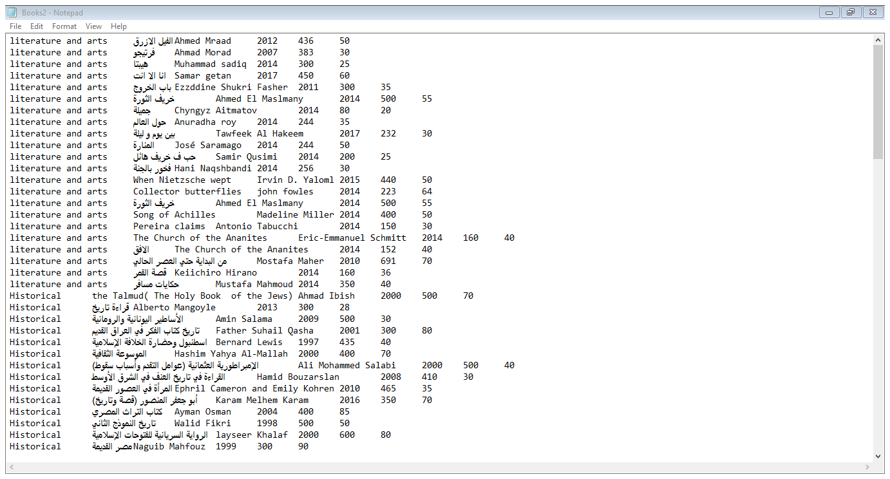

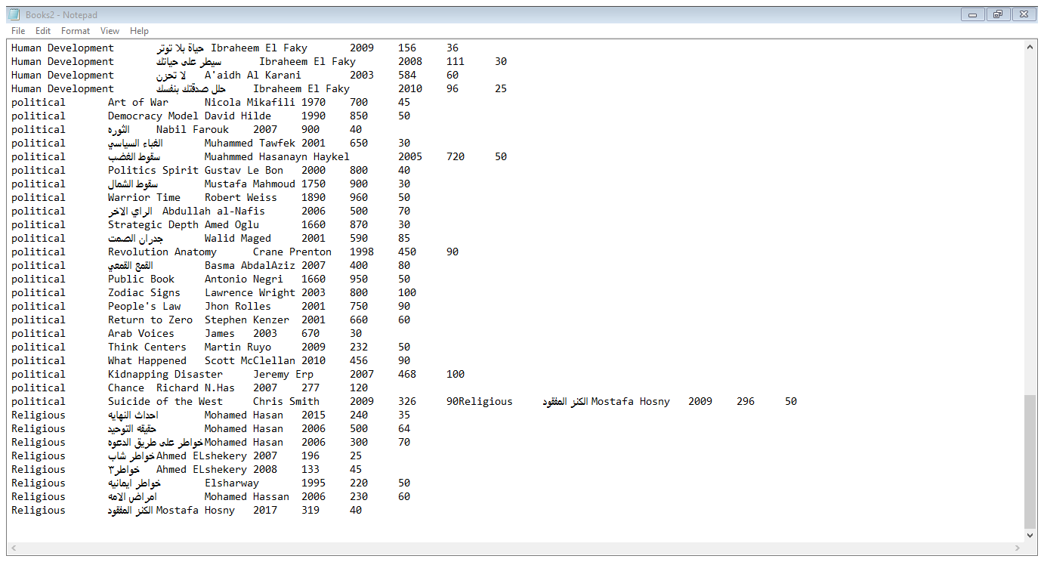

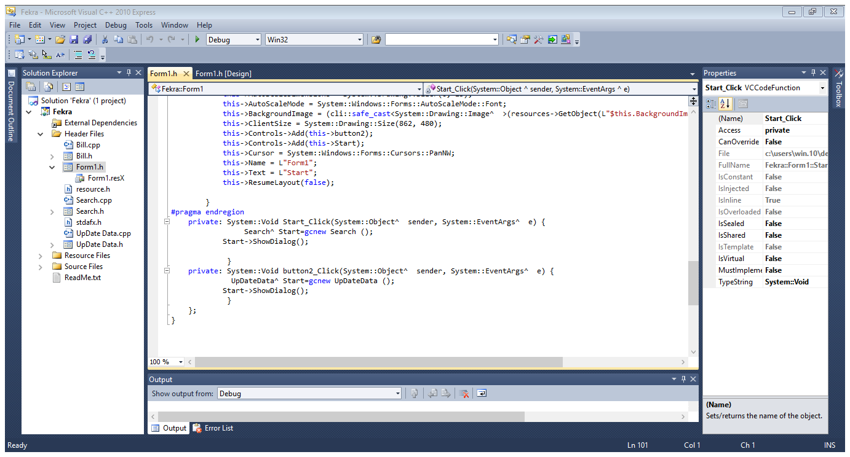

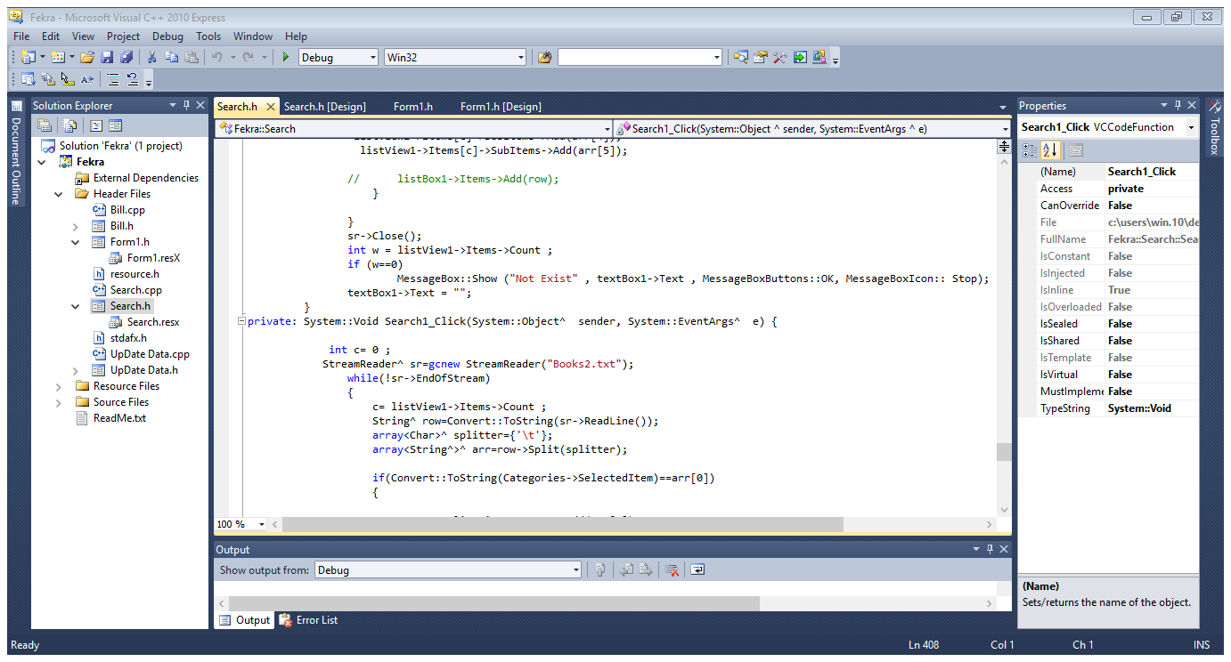

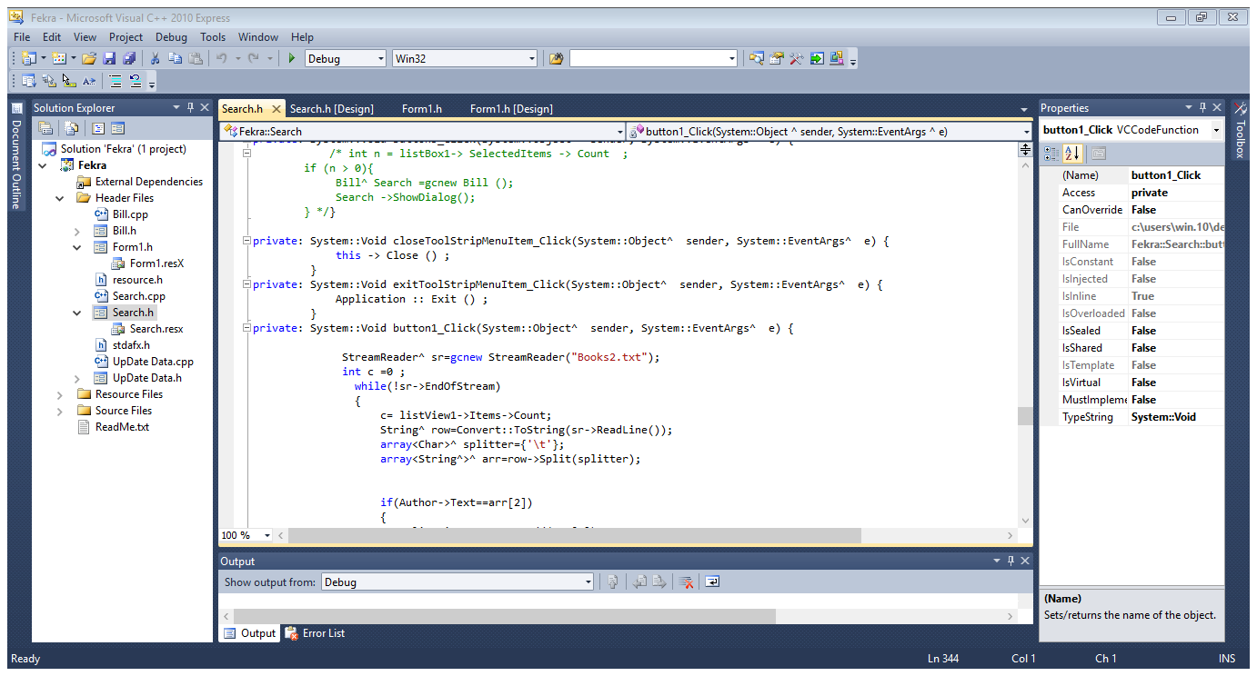

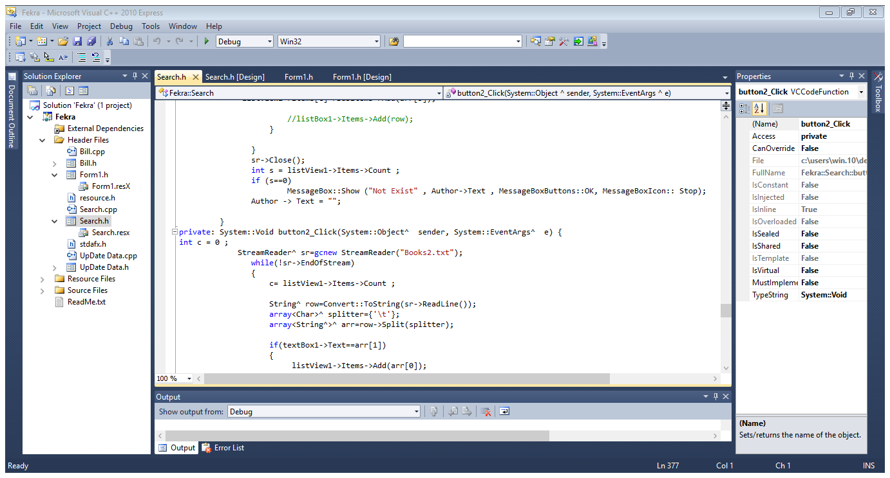

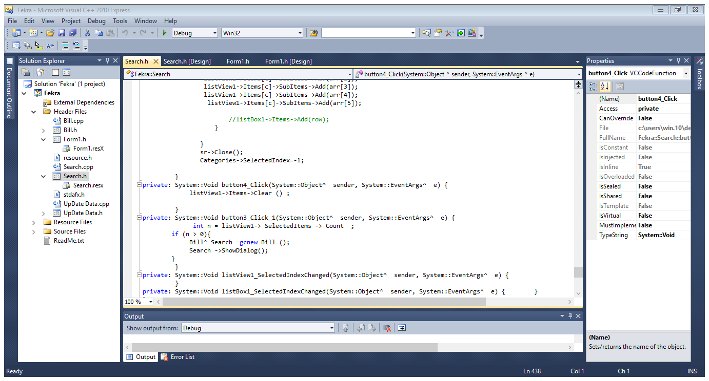

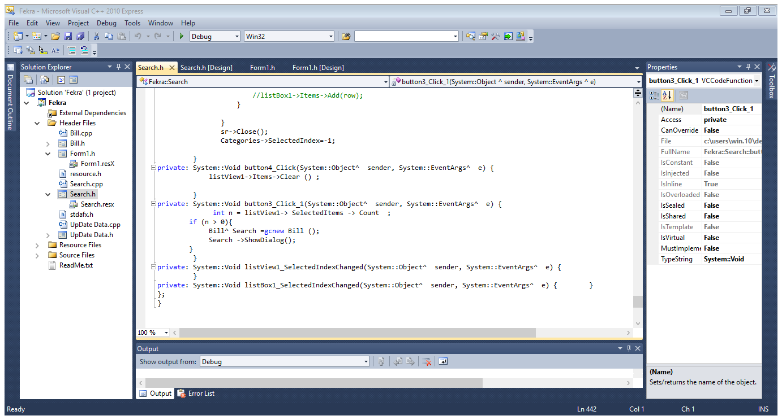

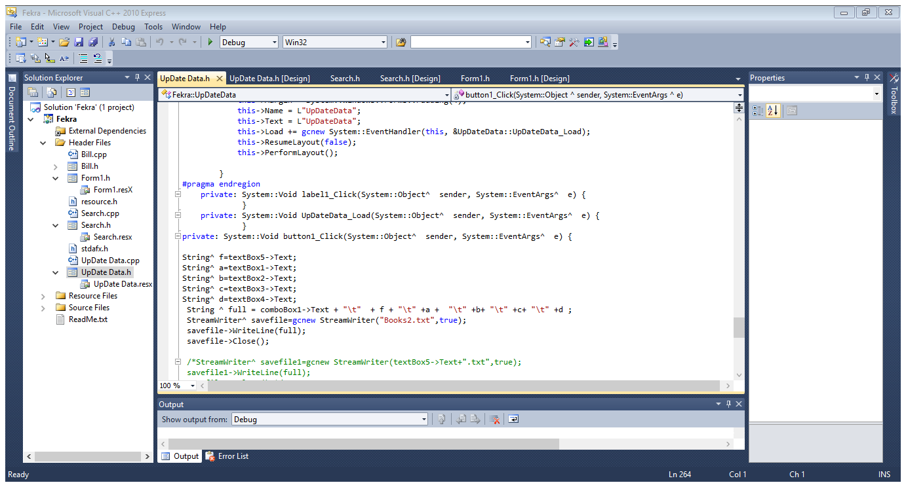

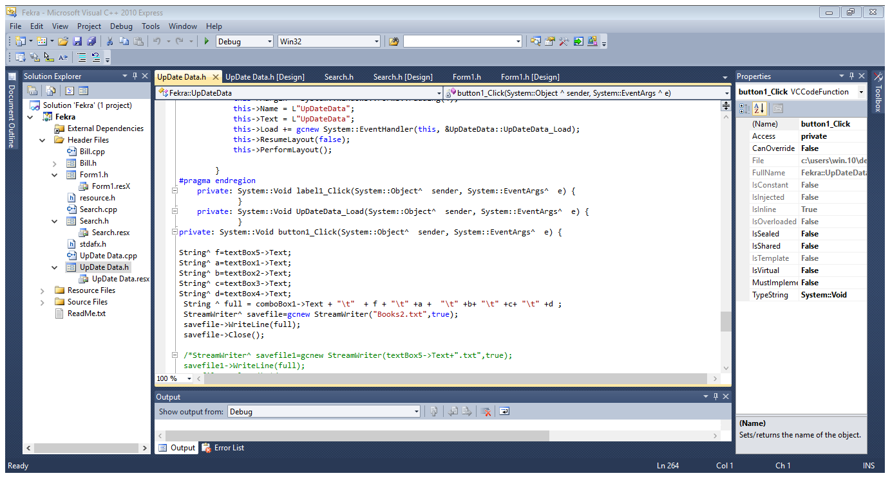

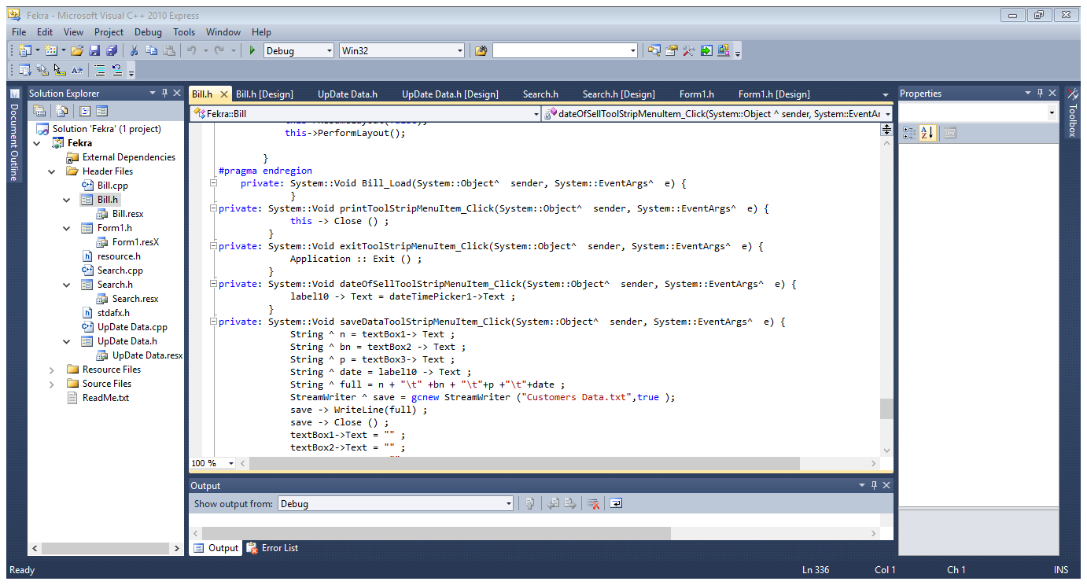

**Examples**

**The first example:- if we want to search about abook named "The Power Of Influence"**

**At first we will press on start program button andthen we will write the name of the book which we want to search for and the information about the book will be shown at the viewList and we will press buy button to move to bill form and fill some information .**

**The second example :-**

**If we want to search for the historical category at first we will press on start program button andthen we will select the category we want to search for from alist o if categories at combobox , the books in this category will shown in the viewList and we Will Select at Item press buy button t'ko move to bill form to fill information .**

**Improvements and Extensions**

**Some improvements can be added to this project such as Complete billing system and location to search for any invoice and print easily, Make special price lists for your customers , Register discounts for a specific customer or multiple customers .**

**The weak points of the project is Shorten searches on Arabic and English books only , Do not support other languages.**

**The strong points of the project is The possibility of searching for books in many ways such as searching a book by category or book name or author .**

**Difficulties Encountered**

**There are some problems that we encountered while working on this project such as shortage of time , Lack of experience , The difficulty of finding the right place that provides calm for the efficient ,**

**implementation of the project , Compiling and linking files Which Took a lot of time .**

**we face a sever problem in order to understand the functionality of View List**

**Conclusion**

**The most Important points of the project are to srearch a particular book using many ways such as searching a book by category , book name or the author .**

**it has the possibility to control the inventory of the book shop , It has the possibility to add new books anytime .**

**it can store the information a bout customers .**